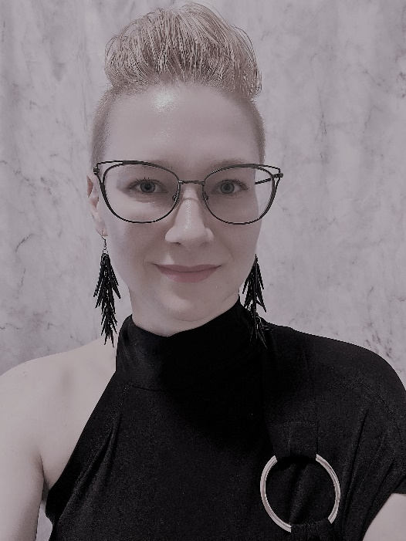
Dr. Inara McMaster is a professional life coach, classically trained musician, artist, designer and specialist physician. Inara left home at the age of 15, living on the street for a year and a half. She dropped out of high school; completing this through distance education while on the street. While living in a youth homeless shelter she spoke on behalf of the organization to the local Council advocating successfully for continued funding. While on the street she experienced a variety of challenges to both her physical and mental health including many forms of abuse, food insecurity, housing insecurity and discrimination. Despite these challenges as a youth she completed high school and was accepted to university while working full time to support herself.
Her first post secondary experience was in nutrition, achieved at the young age of 14 when she was given permission to audit courses at the local community college. Here, she obtained a strong grasp of the value of how proper nutrition plays a role in our well-being. Continuing with her passion for biology, she later earned a BSc in Biology before acceptance to medical school. While obtaining her BSc she helped to establish a mentorship program at Trent University for students wanting to go into medicine which continues to run today. While in residency, she trained in a number of countries around the world including the USA, Thailand and Taiwan. These international residencies gave her experience combining traditional medicinal practices with modern medicine. In her medical career working as a pediatrician in neonatal intensive care units as well as pediatric emergency medicine brought high intensity, high-risk, fast paced situations with little room for error, and at times, while working in areas with poor medical resources. Leading a medical team under stressful conditions and running her private pediatric consultation clinic brings an understanding about the finite balance of leading, mentoring and running a business. A large passion of Inara’s is fashion and interior design as it is a strong reflection of how we view ourselves.
Over her life and career, she has gained skills to help with stress management, relationships, healthy lifestyles, and finding one’s true self. She has gained a deep understanding of how individuals can thrive when the unconventional is the best environment for the unique individual. She would be honoured to help guide you on your path to your unique 180.

Contact her at The180LC@pm.me for further information or to book a free 45 minute consultation.

